Name – Shayan Mandrekar
Roll No. – E042

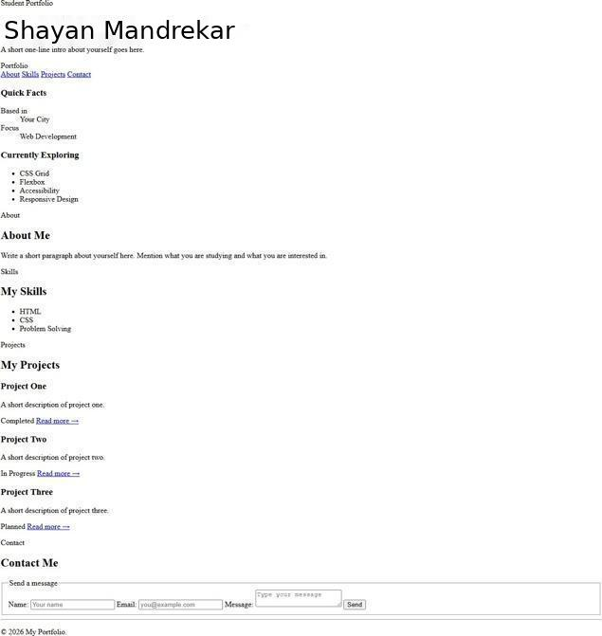
Q1 —Reset & custom properties
Before:
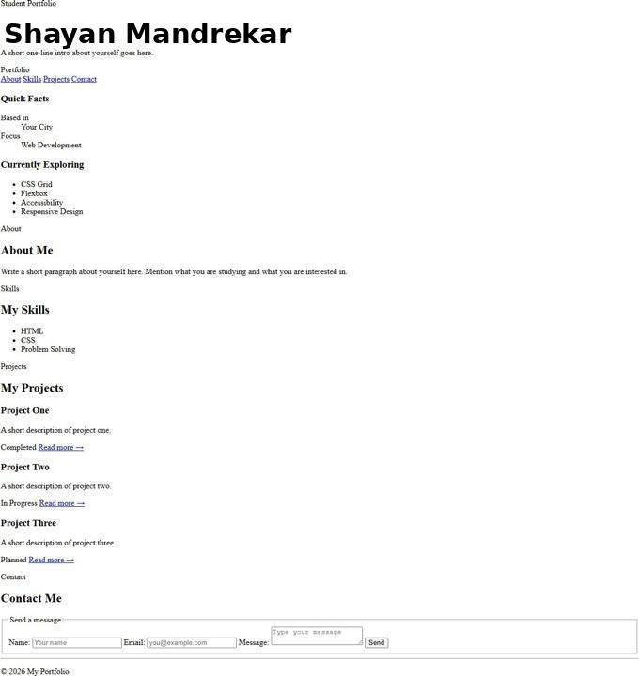
After:
Code added/changed:
*,
*::before,
*::after {
box-sizing: border-box;
}
:root {
--brand: #2f6fed;
--brand-dark: #1f4fb0;
--spacing: 1rem;
--radius: 8px;
}

Q2 —Selectors, combinators & pseudo-classes
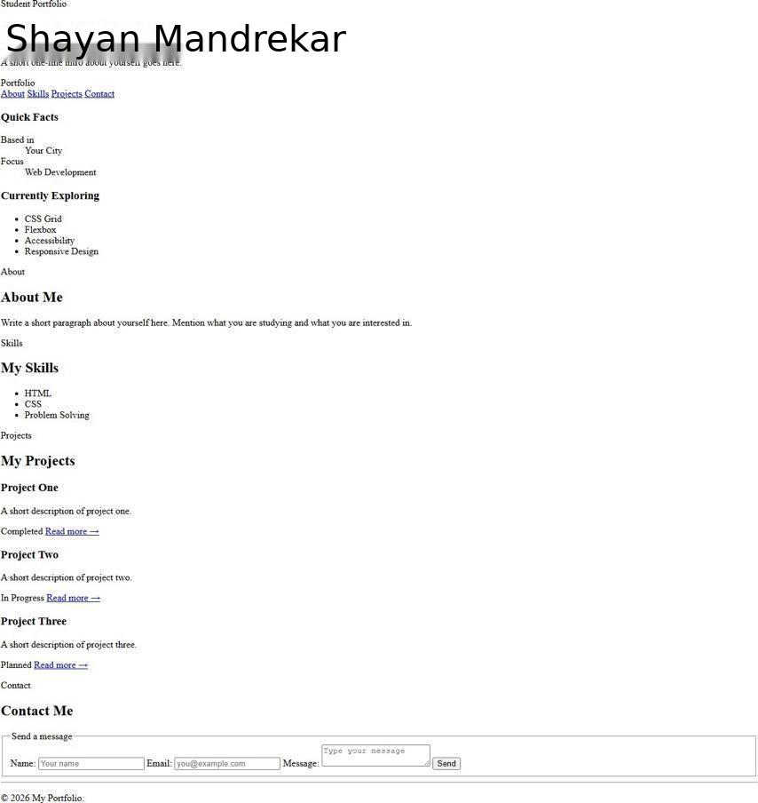
Before:
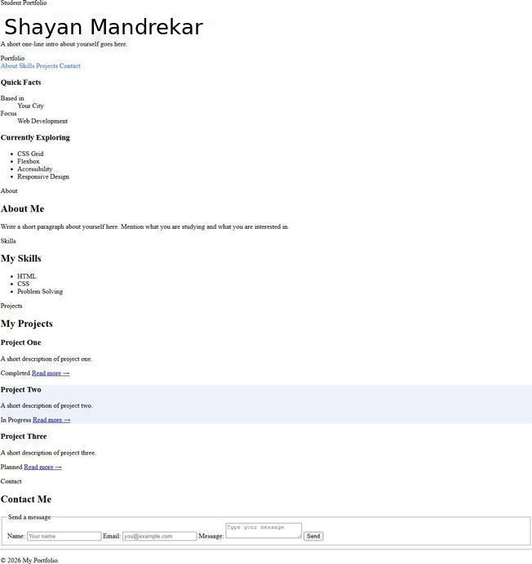
After:
Code added/changed:
.nav-links a {
color: var(--brand); text-decoration: none;
}
.nav-links a:hover {
color: var(--brand-dark);
text-decoration: underline;
}
.cards .card:nth-child(even) { background-color: #eef2fb;
}
input:focus-visible, textarea:focus-visible {
outline: 2px solid var(--brand); outline-offset: 2px;
}

Q3 — Box Model
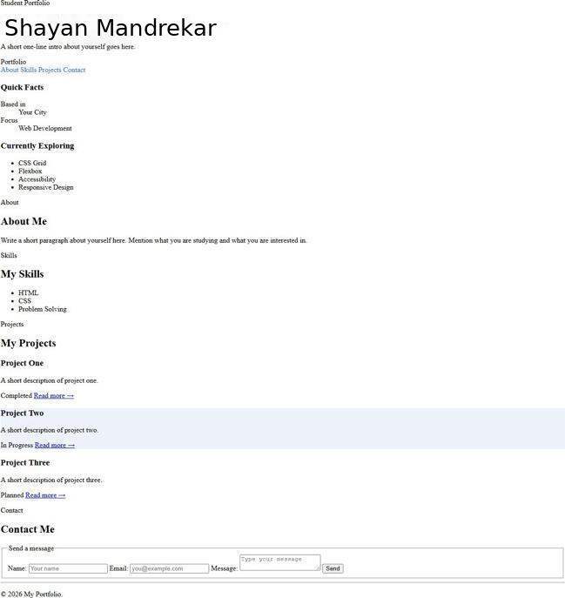
Before:
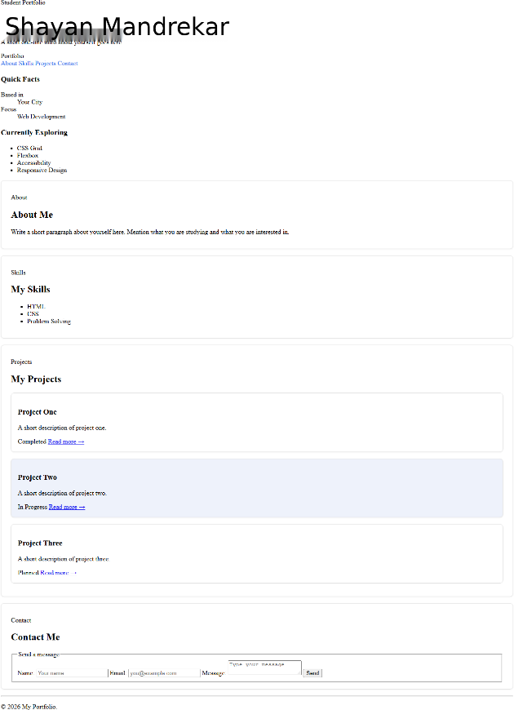
After:
Code added/changed:
<thead>
.block {
padding: var(--spacing) calc(var(--spacing) * 1.5); margin-bottom: var(--spacing);
border: 1px solid #e2e2e2; border-radius: var(--radius);
box-shadow: 0 1px 3px rgba(0, 0, 0, 0.06);
}
.card {
padding: var(--spacing); margin-bottom: var(--spacing); border: 1px solid #e2e2e2; border-radius: var(--radius);
box-shadow: 0 1px 3px rgba(0, 0, 0, 0.06);
}
Q4 — Typography
Before:
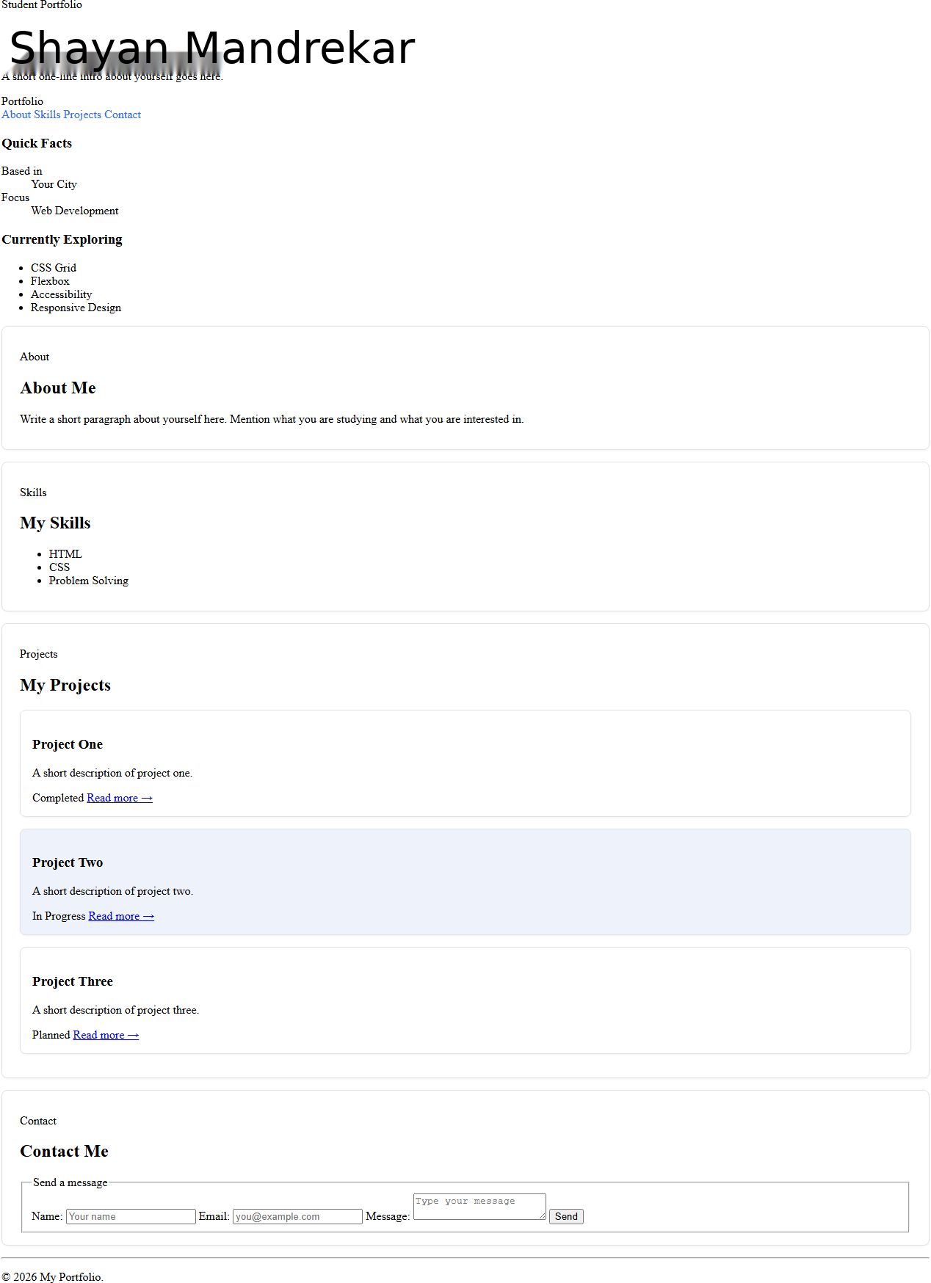

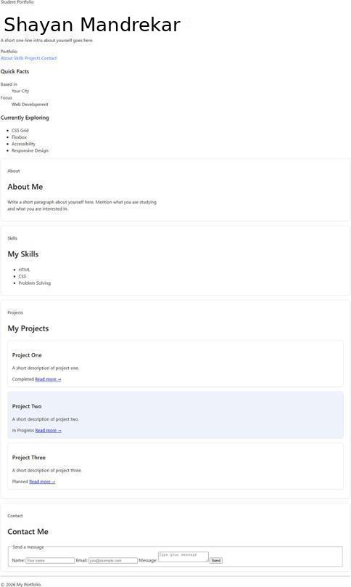
After:

Code added/changed:
body {
font-family: "Segoe UI", Roboto, Helvetica, Arial, sans-serif; line-height: 1.5;
color: #222;
}
h1 {
font-size: 2.5rem; font-weight: 700;
}
h2 {
font-size: 1.75rem; font-weight: 600;
}
h3 {
font-size: 1.25rem; font-weight: 600;
}
p {
font-size: 1rem; font-weight: 400;
}
.block p {
max-width: 65ch;
}

Q5 — Flexbox: navbar
Before:
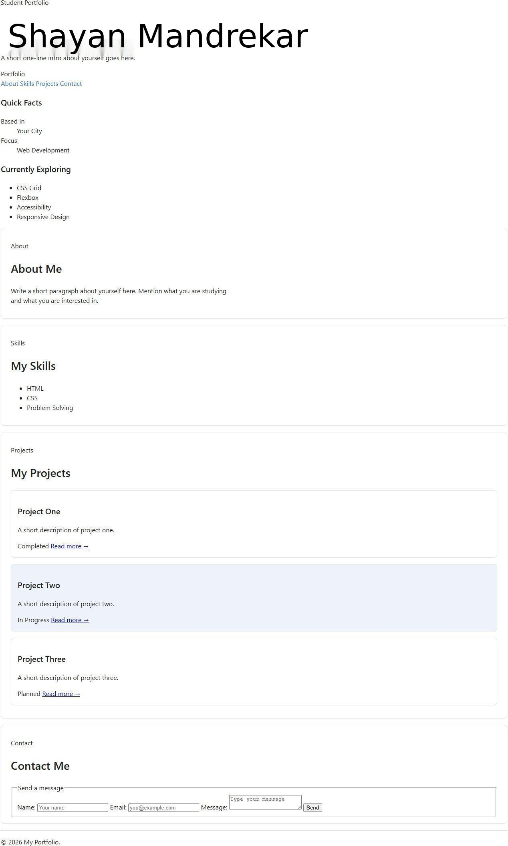
After:
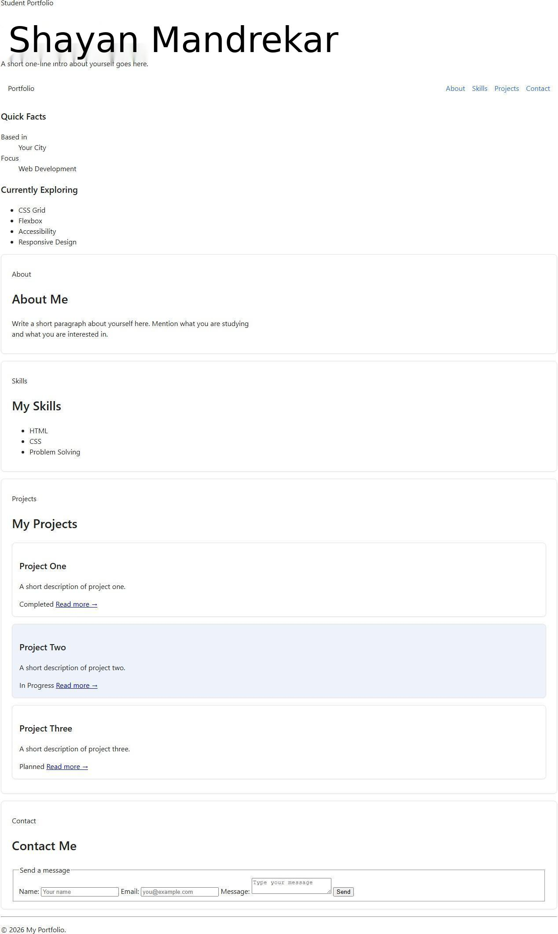
Code added/changed:
Code added:
.navbar {
display: flex;
justify-content: space-between; align-items: center;
padding: var(--spacing);
}
.nav-links {
display: flex;
align-items: center; gap: var(--spacing);
}

Q6 — Flexbox: card meta row
Before:

After:
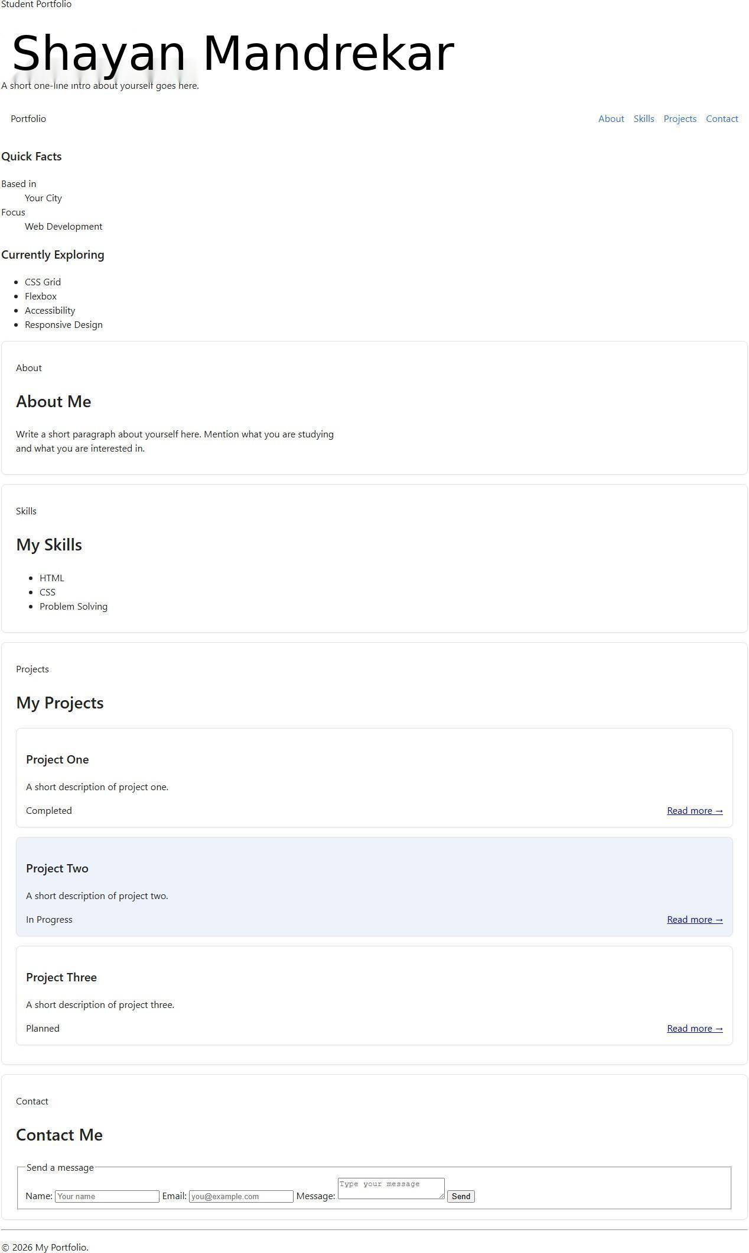
Code added/changed:
.card-meta { display: flex;
justify-content: space-between; align-items: center;
}

Q7 —Grid: page skeleton
Before:


After:

Code added/changed:
/* .page itself switches to display: grid inside the Q9 media query (mobile-first). These grid-area assignments do nothing until then --they only take effect once the parent is actually a grid container. */
.page-header {
grid-area: header;
}
.navbar {
grid-area: navbar;
}
.sidebar {
grid-area: sidebar;
}
.content {
grid-area: content;
}
.page-footer {
grid-area: footer;
}

Q8 — Grid: card gallery
Before:


After:
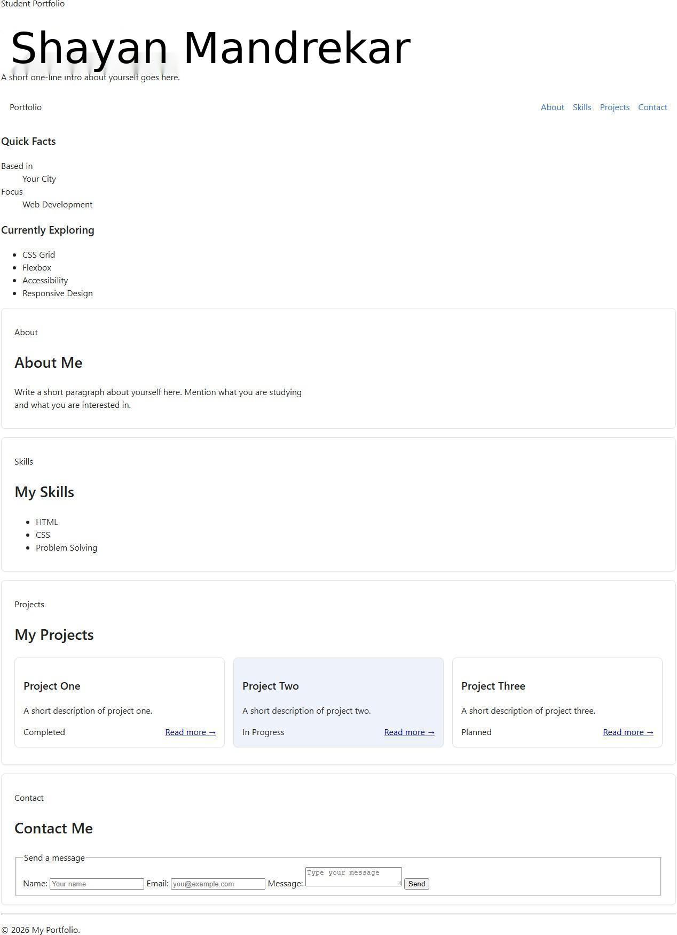
Code added/changed:
.cards {
display: grid;
grid-template-columns: repeat(auto-fit, minmax(220px, 1fr)); gap: var(--spacing);
}

Q9 —Breakpoint 1: activate page grid
Before:


After:
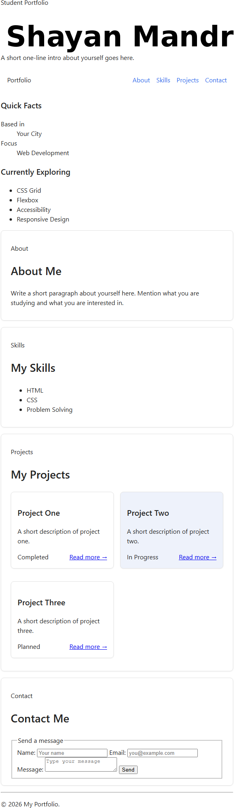

Code added/changed:
@media (min-width: 768px) {
.page {
display: grid;
grid-template-columns: 220px 1fr; grid-template-areas:
"header header" "navbar navbar"
"sidebar content" "footer footer"; gap: var(--spacing);
}
}

Q10 — Breakpoint 2 + fluid type
Before:
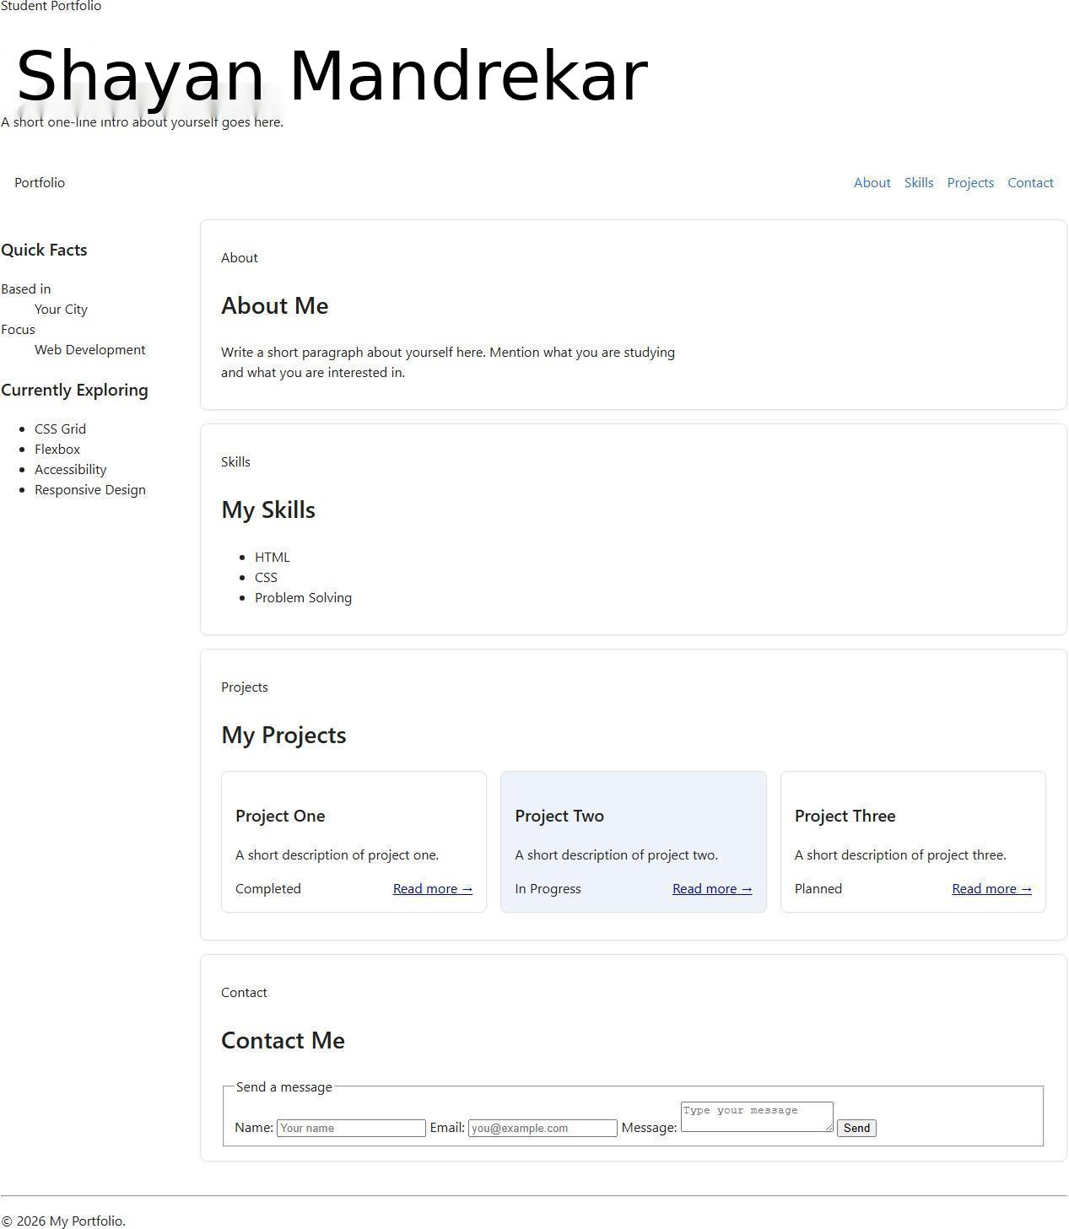

After:
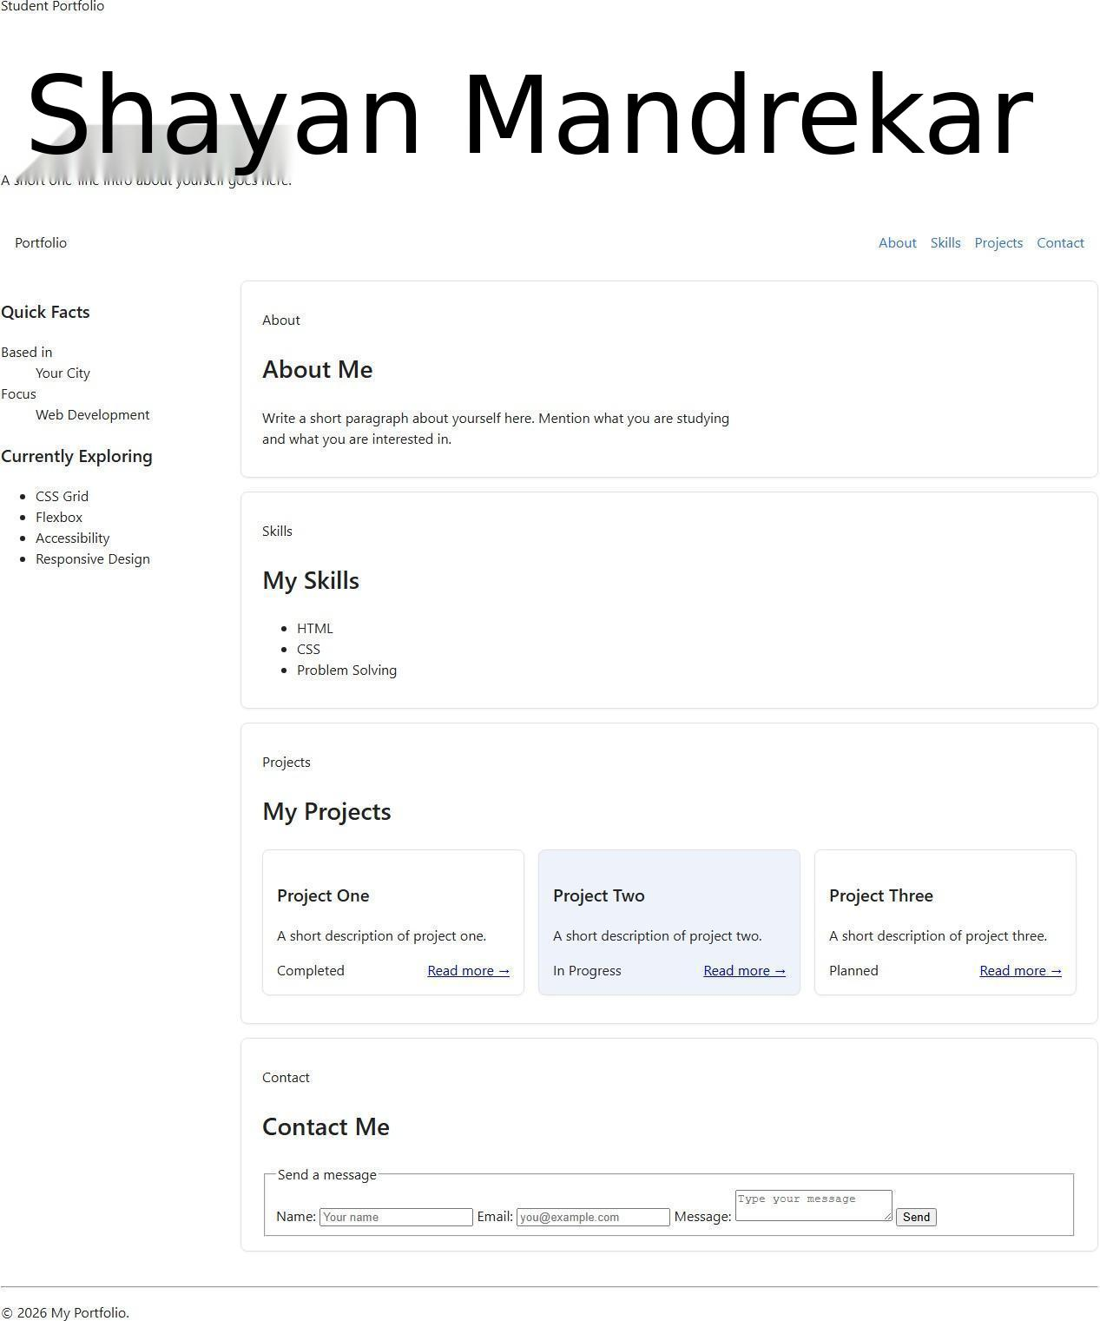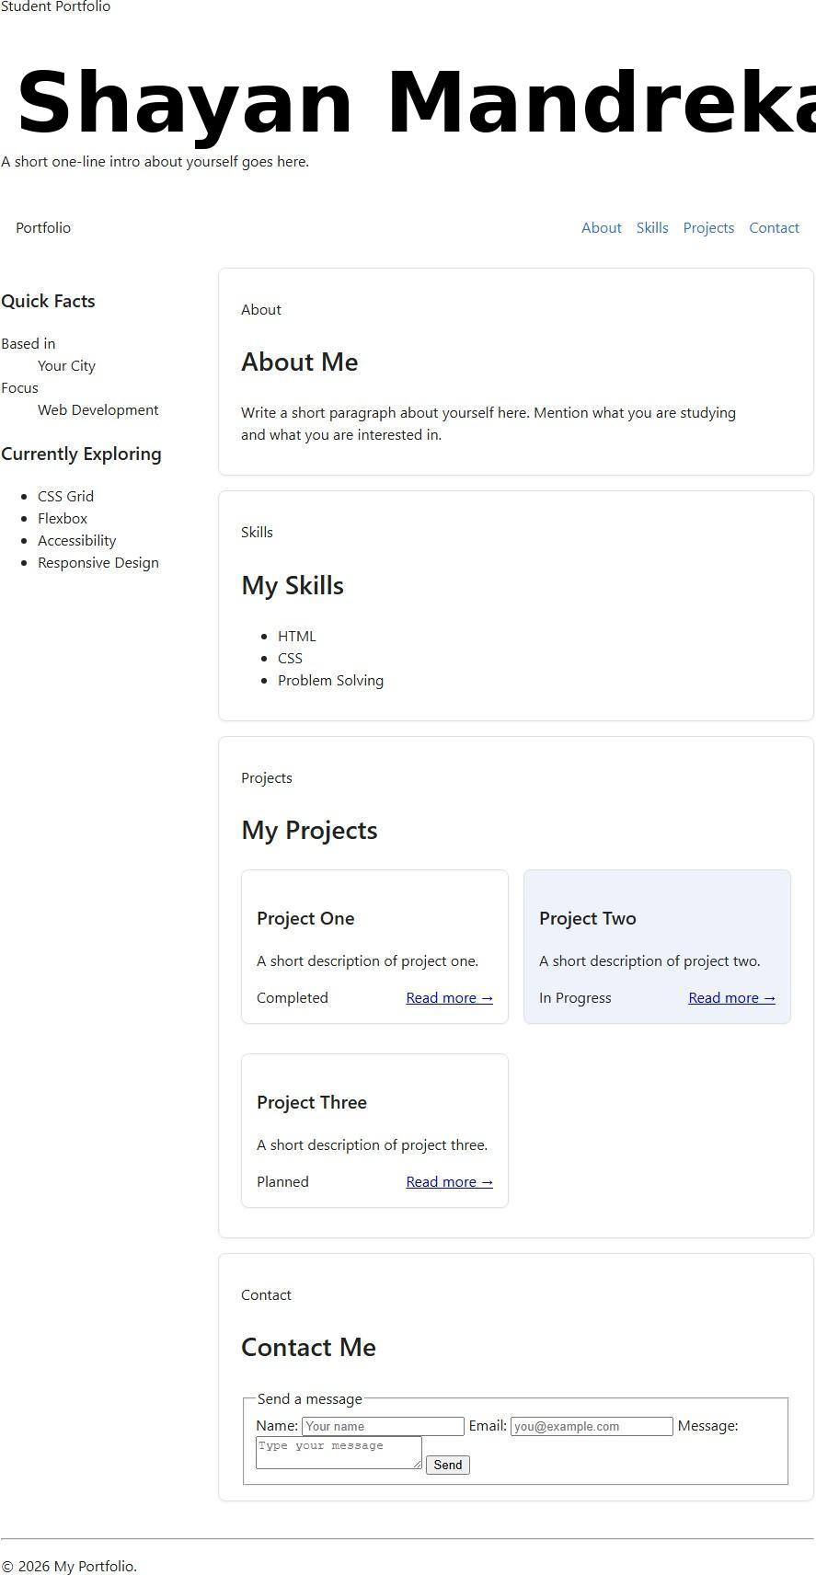
Code added/changed:
@media (min-width: 1024px) {
.page {
grid-template-columns: 260px 1fr;
}
}
.page-header h1 {
font-size: clamp(2rem, 1.5rem + 3vw, 4rem);
}

